IET DEPARTMENT



Data Structure and Algorithm
Lab Manual
Lab 11: Sorting Algorithms
Objectives:
- Sorting
- Selection Sort
- Bubble Sort
- Insertion Sort

Concept Map

Bubble Sort
In the bubble sort technique, each of the elements in the list is compared to its adjacent element. Thus if there are n elements in list A, then A[0] is compared to A[1], A[1] is compared to A[2] and so on.
After comparing if the first element is greater than the second, the two elements are swapped then.

Bubble Sort Technique
Using the bubble sort technique, sorting is done in passes or iteration. Thus at the end of each iteration, the heaviest element is placed at its proper place in the list. In other words, the largest element in the list bubbles up.
We have given a general algorithm of bubble sort technique below.

General Algorithm
Step 1: For i = 0 to N-1 repeat Step 2
Step 2: For J = i + 1 to N – I repeat
Step 3: if A[J] > A[i]
Swap A[J] and A[i]
[End of Inner for loop]
[End if Outer for loop]
Step 4: Exit
Here is a pseudo-code for bubble sort algorithm, where we traverse the list using two iterative loops.
In the first loop, we start from the 0th element and in the next loop, we start from an adjacent element. In the inner loop body, we compare each of the adjacent elements and swap them if they are not in order. At the end of each iteration of the outer loop, the heaviest element bubbles up at the end.
Pseudocode
Procedure bubble_sort (array , N)
array – list of items to be sorted
N – size of array
begin
swapped = false
repeat
for I = 1 to N-1
if array[i-1] > array[i] then
swap array[i-1] and array[i]
swapped = true
end if
end for
until not swapped
end procedure

The above given is the pseudo-code for bubble sort technique. Let us now illustrate this technique by using a detailed illustration.

Illustration
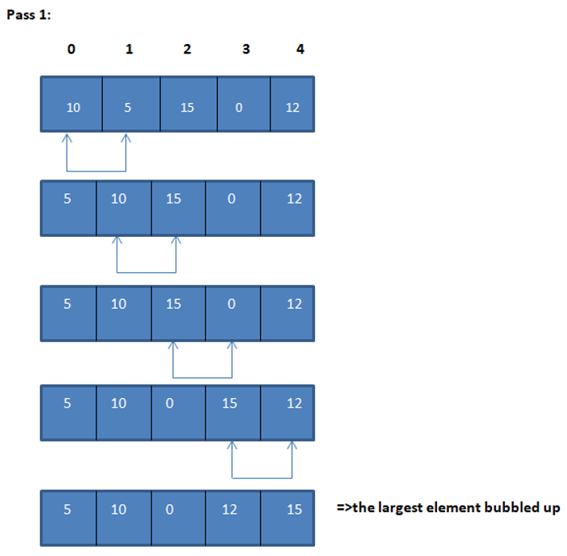
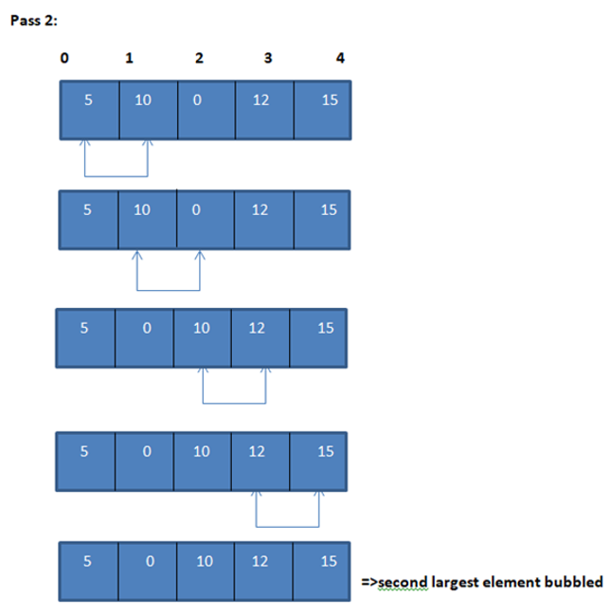
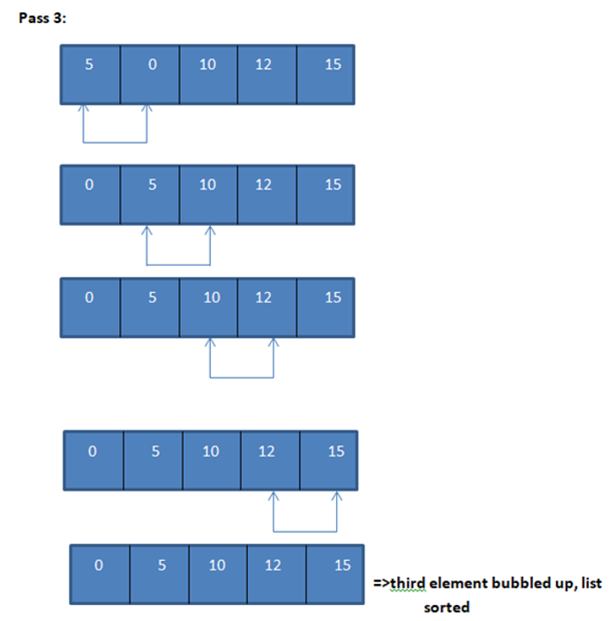

Selection Sort
The selection sort algorithm sorts an array by repeatedly finding the minimum element (considering ascending order) from unsorted part and putting it at the beginning. The algorithm maintains two subarrays in a given array.
- The subarray which is already sorted.
- Remaining subarray which is unsorted.

How Selection Sort Works?
- Set the first element as minimum.
- Compare minimum with the second element. If the second element is smaller than minimum, assign second element as minimum.
- Compare minimum with the third element. Again, if the third element is smaller, then assign minimum to the third element otherwise do nothing. The process goes on until the last element.
- After each iteration, minimum is placed in the front of the unsorted list4.
- For each iteration, indexing starts from the first unsorted element. Step 1 to 3 are repeated until all the elements are placed at their correct positions.

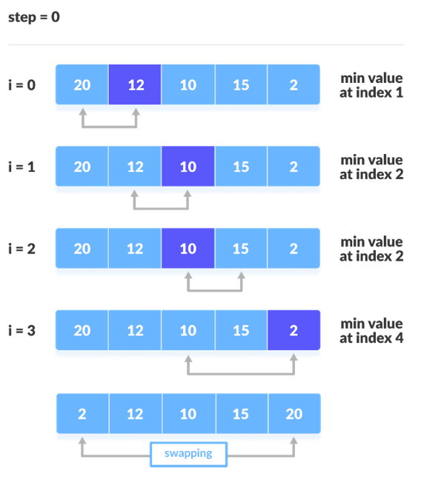
Insertion Sort
This is an in-place comparison-based sorting algorithm. Here, a sub-list is maintained which is always sorted. For example, the lower part of an array is maintained to be sorted. An element which is to be 'inserted in this sorted sub-list, has to find its appropriate place and then it has to be inserted there. Hence the name, insertion sort.
The array is searched sequentially, and unsorted items are moved and inserted into the sorted sub-list (in the same array).
Algorithm:
insertionSort(array)
mark first element as sorted
for each unsorted element X
'extract' the element X
for j <- lastSortedIndex down to 0
if current element j > X
move sorted element to the right by 1
break loop and insert X here
end insertionSort

The first element in the array is assumed to be sorted. Take the second element and store it separately in key. Compare key with the first element. If the first element is greater than key, then key is placed in front of the first element. Now, the first two elements are sorted.
Take the third element and compare it with the elements on the left of it. Placed it just behind the element smaller than it. If there is no element smaller than it, then place it at the beginning of the array.
In a similar way, place every unsorted element at its correct position.

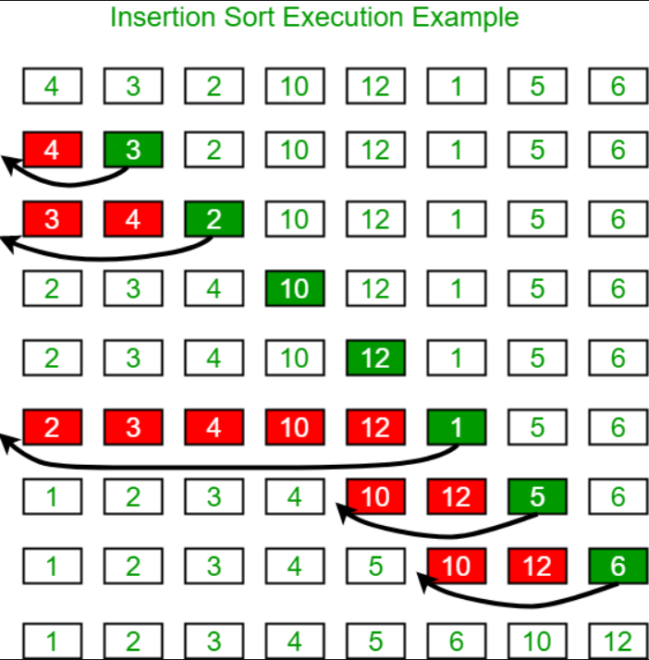

Lab Tasks
Task 1:
Consider a text composed of n lines of up to 80 characters each. The text is stored in an array T where each line T [i] is an array of characters containing words separated by a single space.
Write an algorithm Sort-Lines-By-Word-Count(T) that, with a worst-case complexity of O(n), sorts the lines in T in non-decreasing order of the number of words in the line. (Hint: lines have at most 80 characters, so the number of words in a line is also limited.)

Task 2:
Design a data structure for storing a set of integers.
It should support the following operations:
• Create singly link list using node with data integer as an element
• insert: node into linklist
• sort that linklist: sort using any sorting algorithm (bubble, insertion or selection)
• Display linklist

Home Task
Given an array A and a positive integer k, the selection problem amounts to finding the largest element x ∈ A such that at most k elements of A are less than or equal to x, or nil if no such element exists. A simple way to implement it is as follows:
SimpleSelection(A, k)
1 if k > A.length
2 return nil
3 else sort A in ascending order
4 return A[k]
Example A = (29, 28, 35, 20, 9, 33, 8, 9, 11, 6, 21, 28, 18, 36, 1) k = 6

Write another algorithm that solves the selection problem by sorting (using selection and bubble sort) A.

